1. **Write a program in java to calculate the Simple Interest.**

class SimpInterest

{

public static void main(String args[])

{

float p, r, t, si;

p=3000;

r = 8;

t = 4;

si = (p*r*t)/100;

System.out.println("Simple Interest = " + si);

}

}

**Output:**

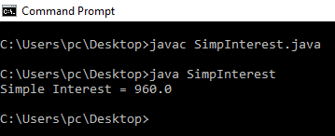

**2. Write a program in java to calculate sum of two numbers input from Command Line argument.**

class Sum

{

public static void main(String args[])

{

int num1, num2, sum;

num1 = Integer.parseInt(args[0]);

num2 = Integer.parseInt(args[1]);

sum = num1 + num2;

System.out.println("Sum = " + sum);

}

}

**Output:**

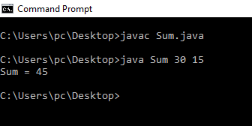**3. Write a program in java to calculate Area of Circle using scanner class.**

import java.util.Scanner;

class AOC

{

public static void main(String args[])

{

int radius;

float area;

Scanner sc=new Scanner(System.in);

System.out.print("Enter Radius of the Circle: ");

radius= sc.nextInt();

area= (float)(3.14*radius*radius);

System.out.print("Area of the Circle: " + area);

}

}

**Output:**

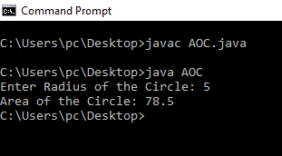

**4. Write a program in java to calculate Square Root of a number.**

import java.util.Scanner;

class mysqrt

{

public static void main(String args[])

{

double i;

Scanner sc=new Scanner(System.in);

System.out.print("Enter a number: ");

i=sc.nextInt();

double n = Math.sqrt(i);

System.out.println("Square root = " + n);

}

}

**OUTPUT:**

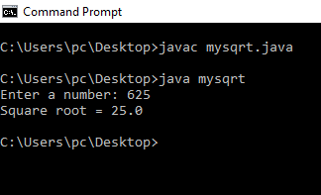

**6. Write a program in java to display Grading of student when his percentage is input from keyboard,**

import java.util.Scanner;

public class Grades{

public static void main(String [] args){

Scanner grades = new Scanner(System.in);

int x = 0;

System.out.print("What is the percentage of the student: ");

x = grades.nextInt();

if (x > 100 || x < 0){

System.out.println("Please put in a percent from 0 - 100!\n");

}

while (x > 100 || x < 0 ){

System.out.print("What is the percentage of the student: ");

x = grades.nextInt();

if (x > 100 || x < 0){

System.out.println("Please put in a percent from 0 - 100!\n");

}

}

if (x <= 100 && x >= 91){

System.out.print("A+");

}

if (x <= 90 && x >= 81){

System.out.print("A");

}

if (x <= 80 && x >= 71){

System.out.print("B+");

}

if (x <= 70 && x >= 61){

System.out.print("B");

}

if(x <= 60 && x >= 51){

System.out.print("C+");

}

if(x <= 50 && x >= 41){

System.out.print("C");

}

if(x <= 40 && x >= 33){

System.out.print("D");

System.out.print("");

}

if(x <= 32 && x >= 0){

System.out.print("FAIL");

}

// so on and so forth down the grading scale

}

}

**OUTPUT:**

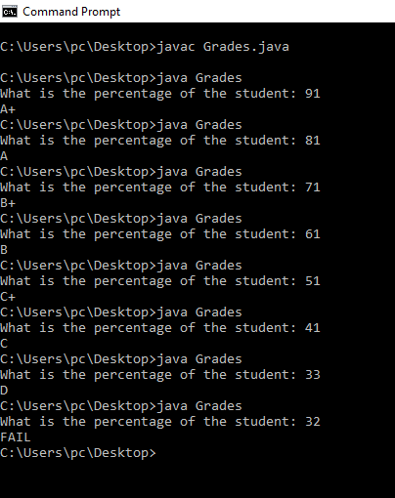

**7. Write a program in java to display Odd Number from 1 to 100.**

class ON

{

public static void main(String args[])

{

System.out.println("The Odd Numbers are:");

for (int i = 1; i <= 100; i++)

{

if (i % 2 != 0)

{

System.out.print(i + " ");

}

}

}

}

**OUTPUT:**

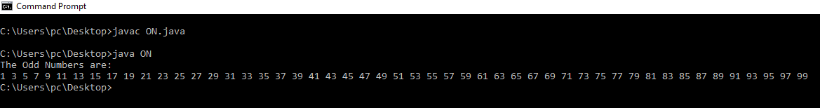

**8. Write a program in java to display the following pattern.**

**1**

**2 2**

**3 3 3**

**4 4 4 4**

**5 5 5 5 5**

class pattern1

{

public static void main(String args[])

{

for(int i=0;i<=5;i++)

{

for(int j=1;j<=i;j++)

{

System.out.print(i + " ");

}

System.out.println();

}

}

}

**Output:**

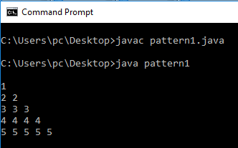

**9. Write a program in java to display the following pattern.**

**1**

**2 2**

**3 3 3**

**4 4 4 4**

**5 5 5 5 5**

import java.io.*;

public class pattern1a

{

public static void printNums(int n)

{

int i, j;

for(i=0; i<n; i++)

{

for(j=1; j<=i; j++)

{

System.out.print(i+ " ");

}

System.out.println();

}

}

public static void main(String args[])

{

int n = 6;

printNums(n);

}

}

**Output:**

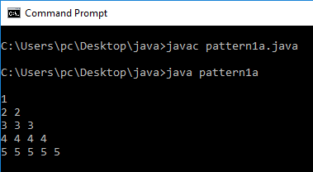

**10. Write a program in java to display the following pattern using function.**

**1**

**1 2**

**1 2 3**

**1 2 3 4**

**1 2 3 4 5**

import java.io.*;

public class pattern1

{

public static void printNums(int n)

{

int i, j, num;

for(i=0; i<n; i++)

{

num=1;

for(j=0; j<=i; j++)

{

System.out.print(num+ " ");

num = num + 1;

}

System.out.println();

}

}

public static void main(String args[])

{

int n = 5;

printNums(n);

}

}

**Output:**

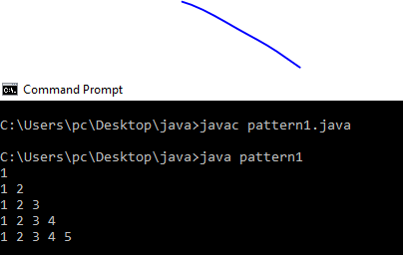

**11. Write a program in java to display the following pattern using function.**

**1**

**2 3**

**4 5 6**

**7 8 9 10**

**11 12 13 14 15**

import java.io.*;

public class patternB

{

public static void printNums(int n)

{

int i, j, num=1;

for(i=0; i<n; i++)

{

for(j=0; j<=i; j++)

{

System.out.print(num+ " ");

num = num + 1;

}

System.out.println();

}

}

public static void main(String args[])

{

int n = 5;

printNums(n);

}

}

**Output:**

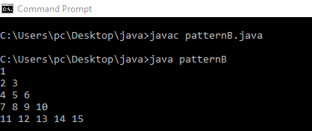

**12. Write a program in java to calculate the Factorial of a number.**

import java.util.Scanner;

class FN

{

static int factorial(int n)

{

if(n==0)

return 1;

else

return(n*factorial(n-1));

}

public static void main(String args[])

{

int i,n;

int f =1;

Scanner sc=new Scanner(System.in);

System.out.print("Enter a number: ");

n=sc.nextInt();

for(i=1;i<=n;i++);

{

f = factorial(n);

}

System.out.printf("\n The factorial of " + n + " is = " + f);

}

}

**OUTPUT:**

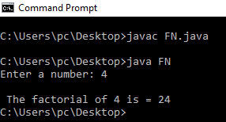

**13. Write a program in java to determine whether a Number input from keyboard is Prime Number or not.**

import java.util.Scanner;

class PN

{

public static void main(String args[])

{

int i;

int j = 2;

int ch = 0;

Scanner sc=new Scanner(System.in);

System.out.print("\nENTER ANY NUMBER: ");

i = sc.nextInt();

while(j<=i/2)

{

if(i%j==0)

{

System.out.print(i +"\n" + "IS NOT PRIME");

ch=1;

break;

}

else

{

j++;

}

}

if(ch==0)

{

System.out.println(I + "\n" + "IS PRIME");

}

}

}

**OUTPUT:**

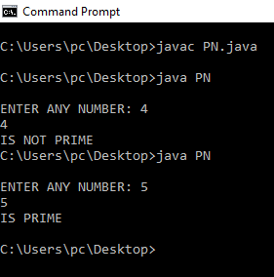

**14. Write a program in java to display the Prime Number from 1 to 500 using function.**

class PrimeNos

{

public static void main (String[] args)

{

int i =0;

int num =0;

//Empty String

String primeNumbers = "";

for (i = 1; i <= 500; i++)

{

int counter=0;

for(num =i; num>=1; num--)

{

if(i%num==0)

{

counter = counter + 1;

}

}

if (counter ==2)

{

//Appended the Prime number to the String

primeNumbers = primeNumbers + i + " ";

}

}

System.out.println("Prime numbers from 1 to 500 are :");

System.out.println(primeNumbers);

}

}

**OUTPUT:**

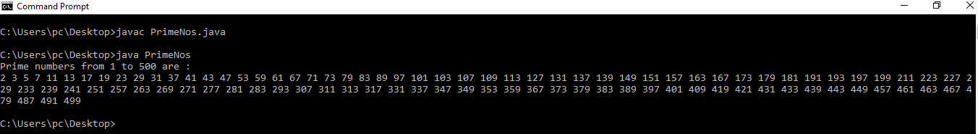

**18. Create a Java Applet and show the use of drawstring() function.**

import java.awt.*;

import java.applet.*;

public class HelloWorldApplet extends Applet{

public void paint(Graphics g) {

g.drawString("Hello World", 100, 100);

}

}

**HelloWorldApplet.html:**

<applet code=HelloWorldApplet.class width=250 height=200></applet>

**Output:**

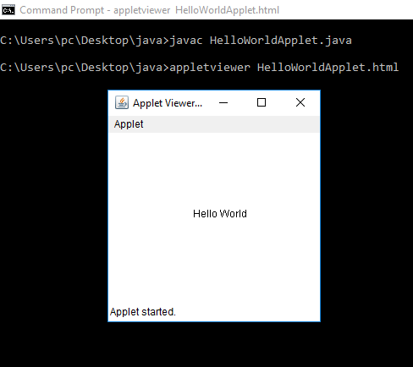

**15. Write a program in java to show accessing Class members and use a dot(.).**

/* define a student class with necessary fields and methods */

class Student {

/* declare the fields of the class */

int roll;

float percent;

/* declare the methods */

void setData(int roll_no, float percentage) { // stores the input data

roll = roll_no;

percent = percentage;

}

void getData() { // displays the stored data

System.out.println("Student Info :- ");

System.out.println("Roll : " + roll + " Percentage : " + percent);

}

}

public class StudentInfo {

public static void main(String args[]) {

Student stud1 = new Student();//create an object to store a student's info

// call setData() to store student's roll and percentage

stud1.setData(7, 73.67f);

Student stud2 = new Student(); // stud2 stores info about another student

stud2.setData(11, 87.43f);

/* display the information about 2 students */

stud1.getData();

stud2.getData();

}

}

**Output:**

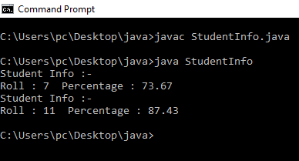

**16. Write a program in java to show Multilevel Inheritance.**

class classA

{

int a=10, b=20;

}

class classB extends classA

{

void sum()

{

int add=a+b;

System.out.println("Addition is"+add);

}

}

class classC extends classA

{

void Product()

{

int mul=a*b;

System.out.println("Addition is"+mul);

}

}

class HierarchicalInheritance

{

public static void main(String args[])

{

classB b=new classB();

classC c=new classC();

b.sum();

c.Product();

}

}

**Outpur:**

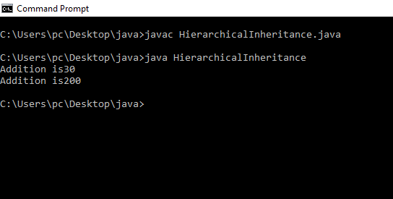

**17. Write a program in java to show Single Inheritace.**

class Super_class

{

int a=10;

void Display_Super()

{

System.out.println("Display on Super Class = value of a is " + a);

}

}

class Sub_class extends Super_class

{

void Display_Sub()

{

System.out.println("Display on Sub Class = value of a is " + a);

}

}

class SingleInheritance

{

public static void main(String args[])

{

Sub_class sub1 = new Sub_class();

sub1.Display_Super();

sub1.Display_Sub();

}

}

Output:

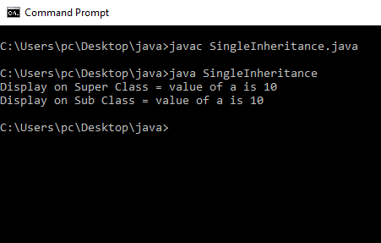

**19.** **Create a java applet to show how to use various methods of applet class and graphics class in a java applet.**

import java.applet.Applet;

import java.awt.*;

public class GraphicsDemo extends Applet{

public void paint(Graphics g){

g.setColor(Color.red);

g.drawString("Welcome",50, 50);

g.drawLine(20,30,20,300);

g.drawRect(70,100,30,30);

g.fillRect(170,100,30,30);

g.drawOval(70,200,30,30);

g.setColor(Color.pink);

g.fillOval(170,200,30,30);

g.drawArc(90,150,30,30,30,270);

g.fillArc(270,150,30,30,0,180);

}

}

**myapplet.htmi:**

<html>

<body>

<applet code="GraphicsDemo.class" width="300" height="300">

</applet>

</body>

</html>

**Output:**

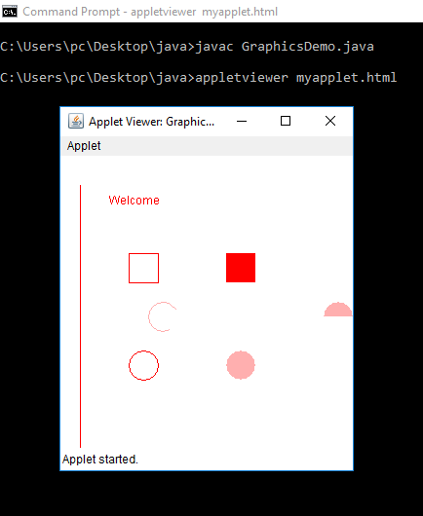

**20. Write a program in java to show the use of Interfaces.**

interface MyInterface

{

/* compiler will treat them as:

* public abstract void method1();

* public abstract void method2();

*/

public void method1();

public void method2();

}

class Do implements MyInterface

{

/* This class must have to implement both the abstract methods

* else you will get compilation error

*/

public void method1()

{

System.out.println("implementation of method1");

}

public void method2()

{

System.out.println("implementation of method2");

}

public static void main(String arg[])

{

MyInterface obj = new Do();

obj.method1();

}

}

**Output:**

